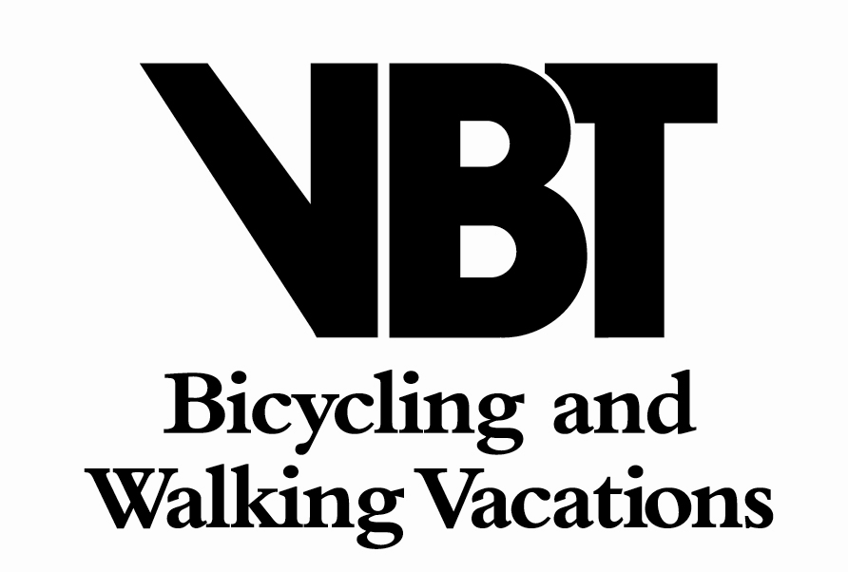

2015 WALKING LEADER APPLICATION FORM

Name: ______________________________________________________________________
Address: __________________________ Phone-cell: _____________________________
__________________________________ Phone-home : ___________________________
__________________________________ E-mail address: __________________________ __________________________________ Skype: __________________________________

Where did you learn about this VBT position? ____________________________________

Language skills
All candidates must be fluent in English. Please indicate your other languages, and level of competence (conversational, proficient, fluent, native)

Essay Questions
Please answer the following (max 300 words per question). Type or print neatly.

- Why do you want to be a VBT tour leader, and what do you hope to gain from the experience of leading tours for VBT?

Drawing on your knowledge of our programs, do you have any local knowledge, knowledge of local flora & fauna, any nature guiding licenses or special experience that would make you an excellent walking leader? If so, please explain.

Additional Information
Please list your hobbies, interests, pursuits and special skills:

If you have tour leading preferences, please list them here. We cannot, however, guarantee work in any particular location.

Scheduling Information
Please indicate any limitations to your schedule from February through December.

Unavailable Dates:

Physical Abilities

Do you have any physical limitations that would prevent you from accomplishing the following tasks?

(circle choice)
Carrying a 30 pound backpack for 4-5 hours? Yes No

Lifting a 23 kg./ 50 lb. suitcase? Yes No

Walking up to 20 km/ 12 miles per day, several days in a row? Yes No

If you answered “yes” to any questions in this section, please attach a separate page with details.

Driving Record
Have you ever driven a 15-passenger vehicle? Yes No

Have you had any driving violations within the last 5 years? Yes No

Have you had any accidents within the last 5 years? Yes No

Have you ever been convicted of driving under the influence of, or driving
while impaired by drugs or alcohol? Yes No

If you answered “yes” to any of questions in this box , please attach a separate page with dates & details.

Complete Applications
Applications accepted year round.
Priority consideration in 2015 will be given to applications received first
Please return completed applications to the e-mail address below.

To be considered complete, your application must contain the following:
- This completed application form, including attached essay question
- A copy of your current resume / C.V.
- List of 2 professional references and their contact numbers & e-mail address
- A copy of your current valid driver's license
- A copy of your current 3-yr certified Motor Vehicle Record
- Completed VBT DOT Driver Application

Interviews
Only selected applicants will be contacted for an interview & mechanical aptitude test.

All statements in this application are true and complete to the best of my knowledge.

Signature: ______________________________________ Date: _______________________

e-mail : vbtdom@vbt.com
Visit our web site at: www.vbt.com

